**Name Ideas**

Portland Metro Homeownership Opportunities Map

Portland Metro Homeownership Affordability Map

Metro Area Homeownership Projections Map

Portland Metro Homeownership Trending Tool

Trends in Portland Metro Homeownership Affordability

Portland Metro Homeownership Needs and Trends

**General Comments**

I thought the example PDF showed some of the basic assumptions as part of the frame (which you included via PDF), I’m not seeing that here. Will that get added into the frame once we approve them, or will people need to go to a separate spot to get to them?

**Portland Housing Affordability**

Is the map showing the assumption of a 20% or a 5% down payment?

2015-2019 are having some kind of technical problem (tried in Firefox and Chrome). The hexes only show up after you’ve hovered over them, so in the progress show it looks blank, but as you move the mouse over them they fill in. See screenshot:

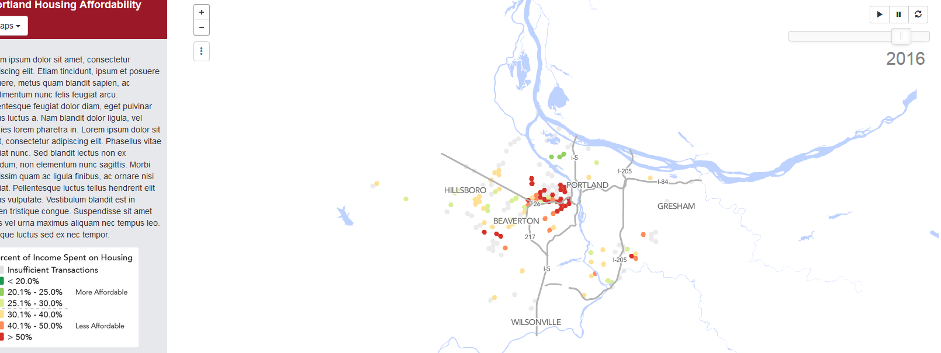

Is there a way to show the assumed sale price and percent of income spent on housing when you click on a hex in the projected period? Similar to how it looks with the median purchase price in the past period, or is that not possible? It’s not showing the 2020 projection screen.

**Displacement Vulnerability Present**

Were we going to show some (or all) of the factors with values when you click a hex? Currently just showing the score which I think people will have a harder time relating to even with the explanation text.

Is 2020 the only projected year on this? It looks like it skips from 2014 to 2020.

Is the score “0” for grey hexes, or is there insufficient data (like the affordability map)? I’m wondering if we should choose a different color than grey since we used it in a previous map for “insufficient data”. When I switched from the first to the second map my immediate thought was that those were areas of insufficient data as well, until I looked at the legend. That might confuse people.

See webtext suggestions for more context here- Is there a way to apply a filter to the map – use another color to indicate those areas that have “turned?” In other words, use an overlay that identifies tracts that were previously “very vulnerable to displacement” and have now increased (income, education, owners vs. renters) and/or lower levels of diversity? *Bates calls these areas “Continued loss” in her neighborhood typology maps (2013).

**Housing Tenure**

There’s something off in the projected screen (2020) with the tenure percentages and the hex color in Hillsboro and North Portland (possibly others), where the color matches the 90% + but the hex says a value under 90% when you click it. Not sure what’s going on there, but it’s probably something that should be resolved before we go live. See screen shot:

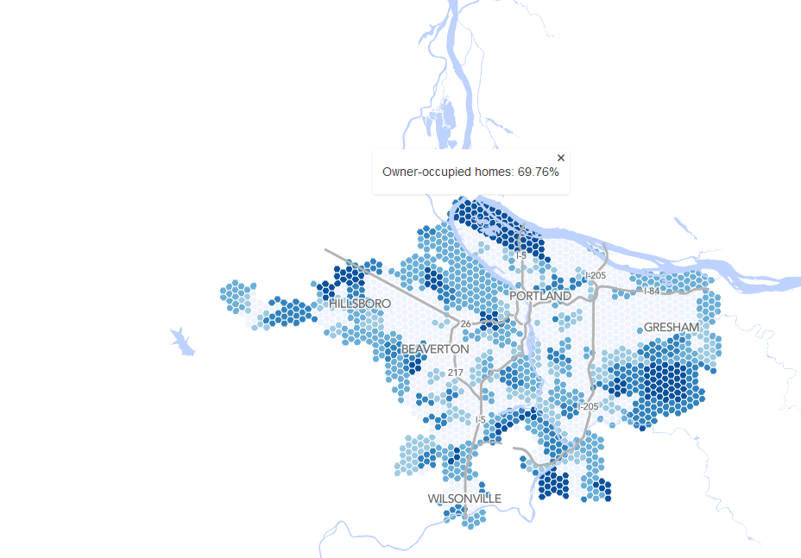

Is 2020 the only projected year on this? It looks like it skips from 2014 to 2020.